Sussex Bay workshop:

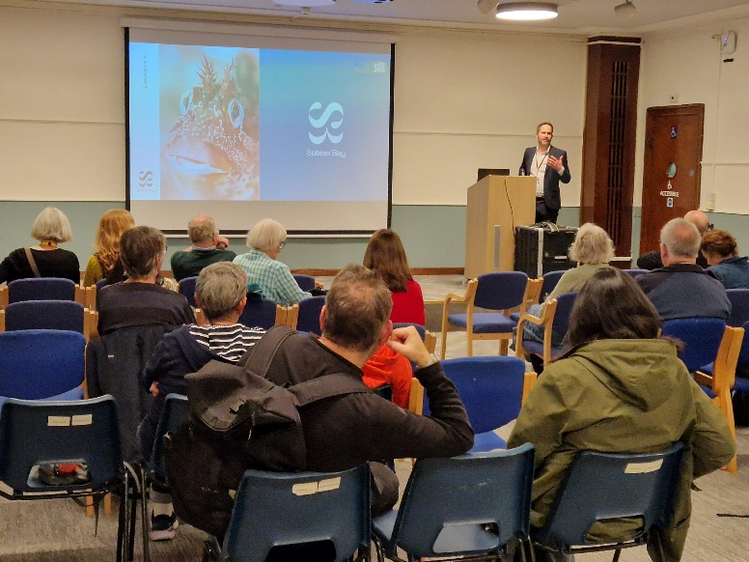

Blue impact: kelp beds of WSx and dramatic loss since mid 80s 176km square of habitat lost.
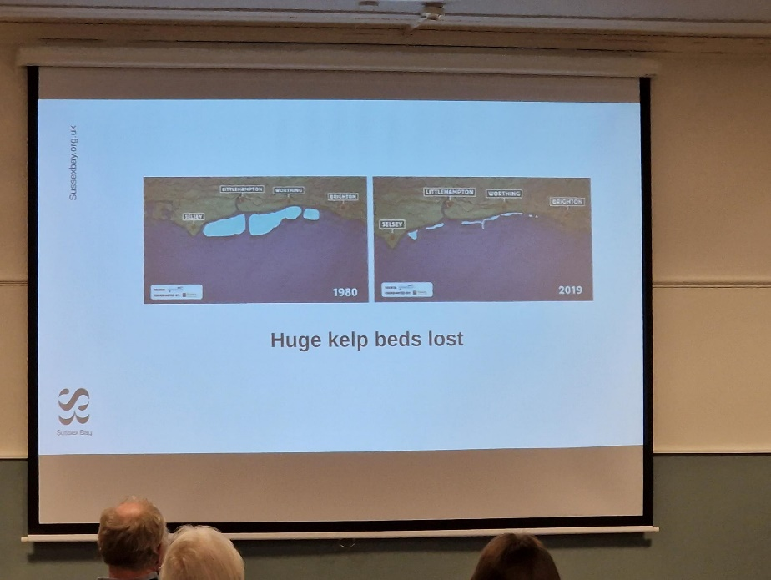

Bottom trawling damaged roots of kelp. By-law mean bottom trawling banned to give sea endurance to recover. Kelp Recovery Steering Group - programme of research and engagement re recovery of kelp forest. Concerns re climate change and will it re-establish. Dredging for gravel and dumping causes cloudy water column. Productivity of kelp - lobsters, nursery groups for fish.

Not got connected thinking re river catchment and impact on sea so Sx Bay could meet that need. Worthing coast consider coastal defence. Environment Agency transitioning re homes at risk. Eastbourne coastal defence scheme £300m needed to save those home. And looking at nature based solutions to minimise impact of coastal pressures ie coastal reefs and biogenic reefs to allow habitat to form. Seaweed agriculture also reduces impact of waves etc. Kelp forest is WSx solution. And Adur River restoration project - finding parcels of land to restore to Salt Marsh and wetland. Scope for recovery for learning in The Adur, Ouse etc.

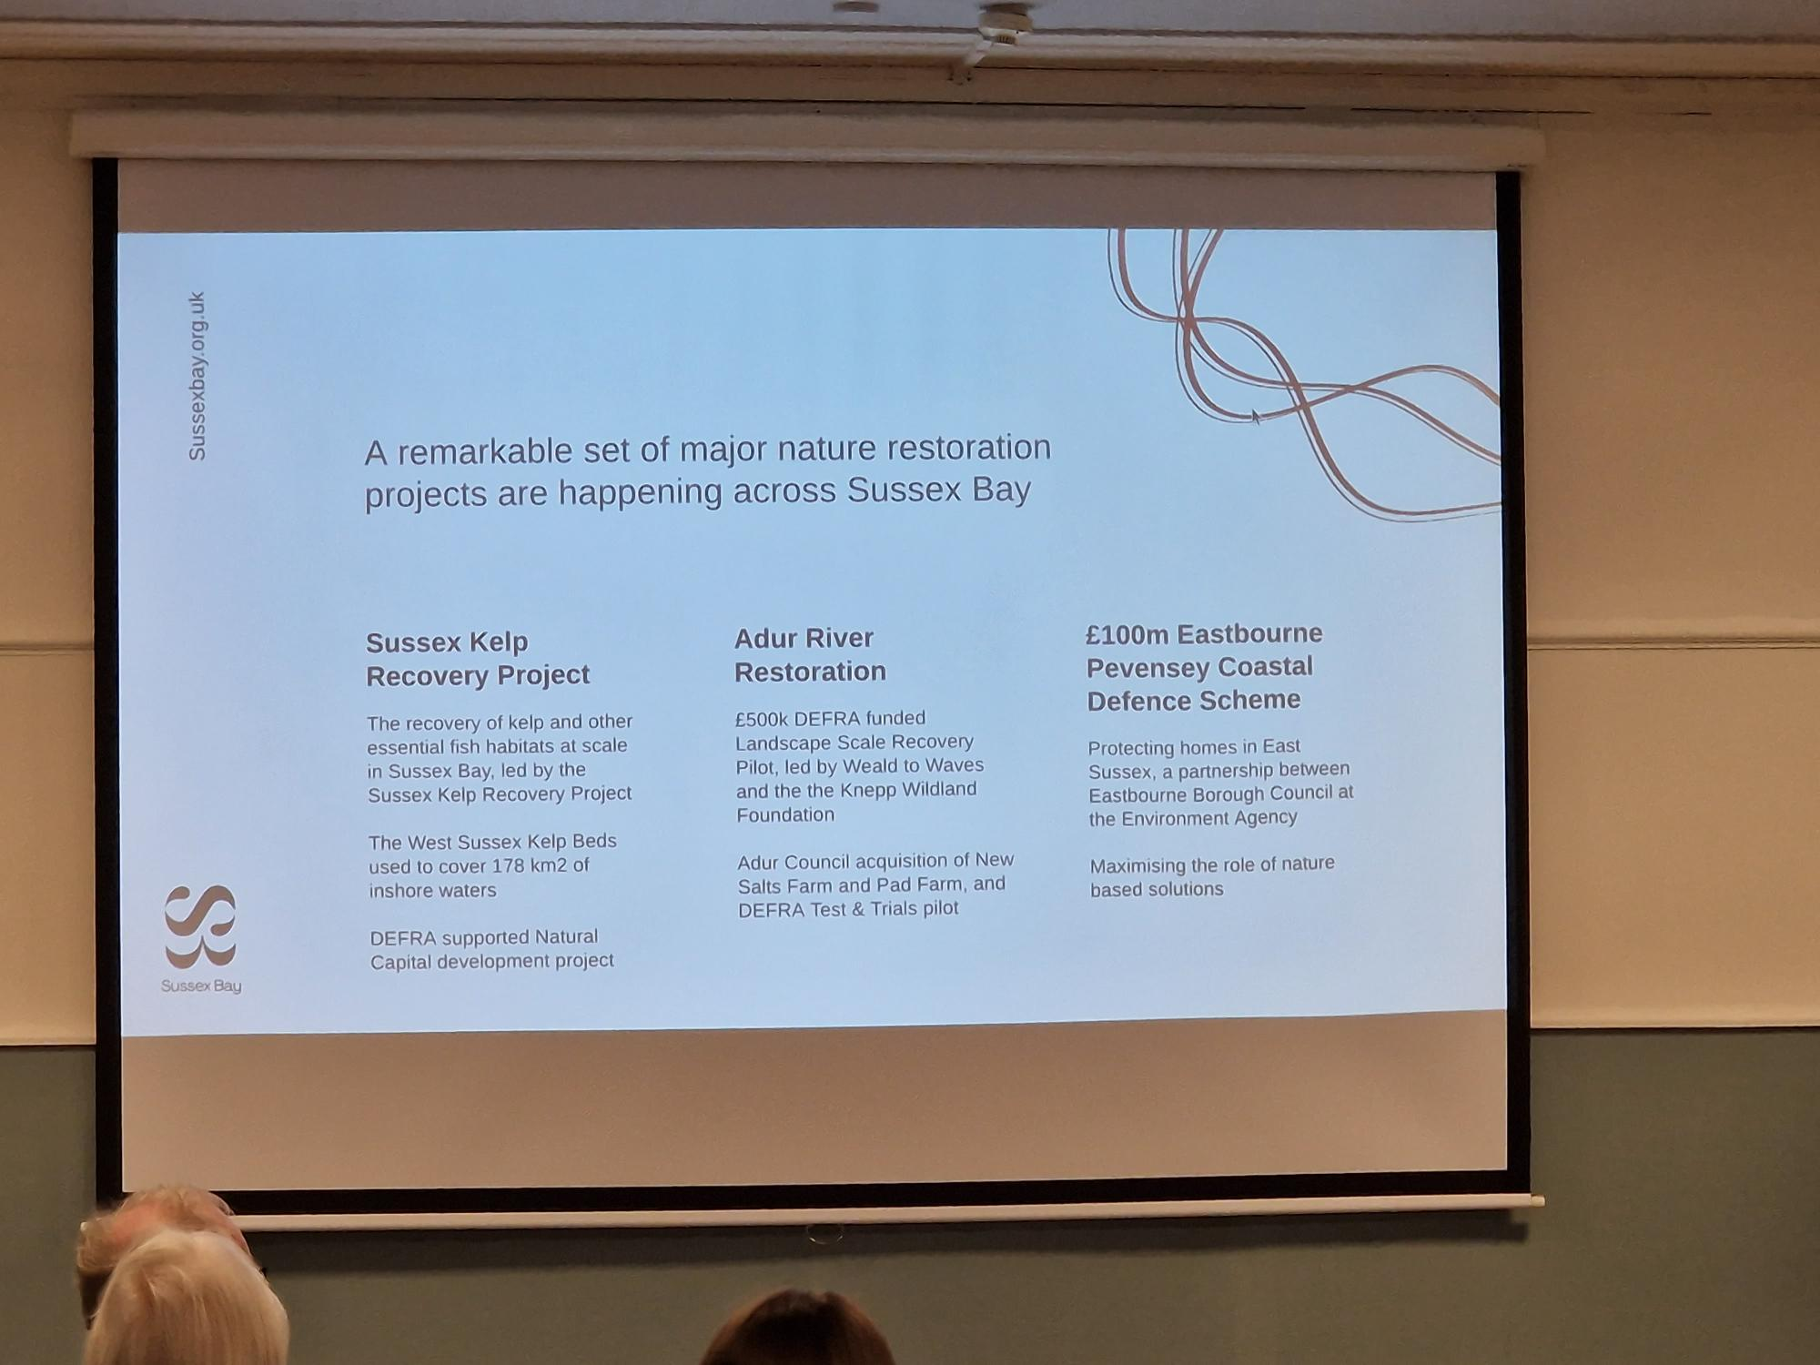

How organise selves to work at scale. "Blue mirror to the south downs" = Sussex Bay. Bidding with partners
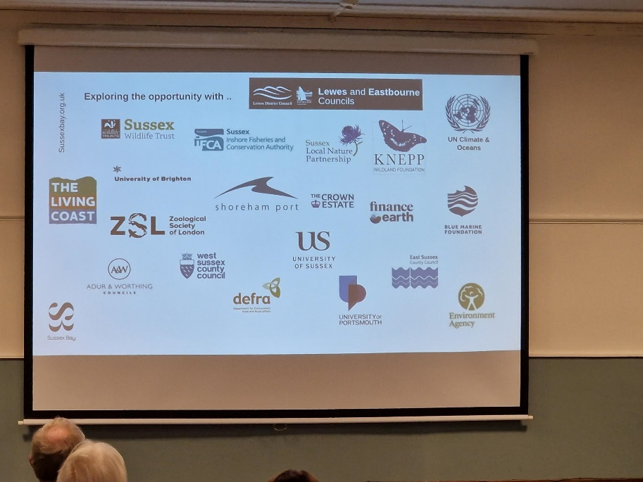

Then Blue slide is vision & mission.
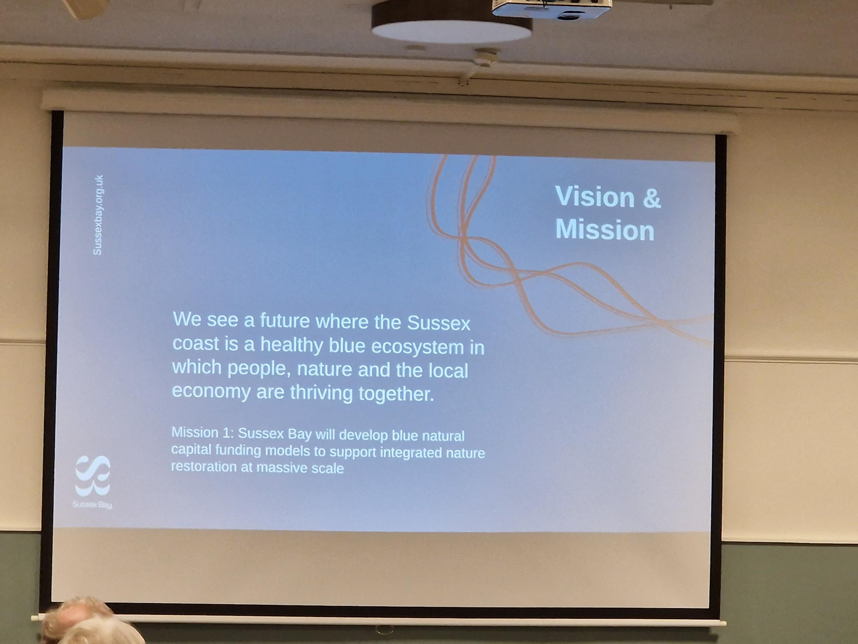

AWC incubating - slide. Appointed Head of Blue Natural Capital due to start. Seabed owner is crown estate so easy negotiations and innovation partnership with crown estate. Looking at how valuable natural assets can be - looking at seabed lease for nature as new initiative (first time considering). Regulatory landscape much more complicated (see 4 bullet in slide) and bringing around the table. Got participation from agencies. Nature recovery - not enough public money. Govt funds can only start work so rely on private money - Propellernet, Bird & Blend ethical standards. Coastal communities fund - seascape restoration strategy - plan of Blue Susse and identify need. Natural capital baseline assessment: natural value of what’s there already. In this bid need community participation (including this workshop) how connect people to consider this. Tackle social exclusion, look at new careers from this. Launch World Ocean Day 8 June 2024 hopefully.

Future missions - hoping to release money and engagement to get projects going. And then engage on future missions issues. Aquaculture - seaweed aquaculture etc. Collecting fishing gear and in Cornwall make products from it (cups, sunglasses etc). Generate income using those products? Sx Wildlife Trust got great projects with school kids etc, gathering data like bird counts that exist but with sea. Eric Smith Our Lives - advocate of moving out to that scape. Eco tourism. Connect.

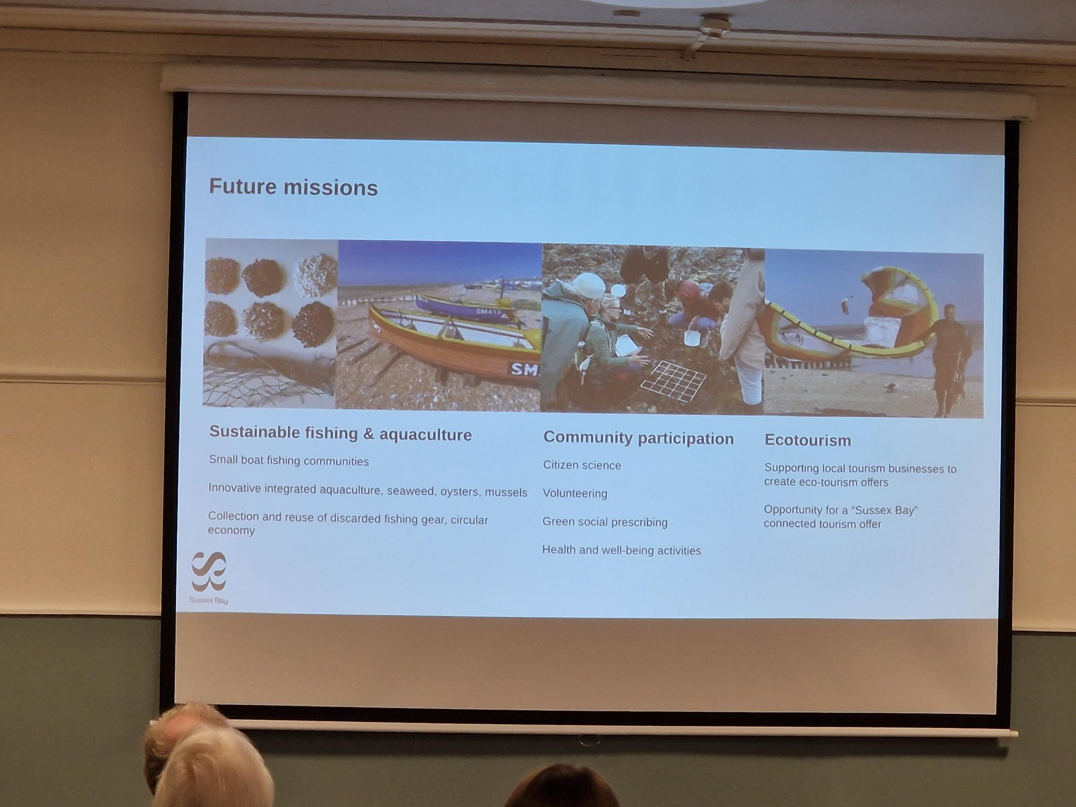

Work with LA in general, need to connect with community groups and join movement here this afternoon for benefit of nature and communities. £170k to Worthing community groups already and more activity going on. Covers whole of Sx coastline. Right scale to think and work at.

Q: 1 solution for kelp issues- storm/trawler damage coastal erosion and land reclamation- propose A27 lots problems with traffic along all sections. Possible road going Selsey to Eastbourne to take traffic but go on top of wall across the bay to protect kelp from fishing. Protect against flooding and allow land relation on lagoon side. P: think about seascape recovery strategy - lots of different angles on habitat. Bay is not going to be highly protected area but ideas like this and other uses of marine environment bring together and consider all perspectives and how reconcile various ideas. Studland Bay project to restore Seagrass, traditionally leisure users dripped anchor there. Now families enjoying that space and legitimate stake in that place - with engagement done well they've become advocates for it. Maintain conv. Bringing in ideas into seascape restoration strategy.

Q: today was feeling pessimistic about this, now hearing it feels amazing. Communicate message. Didn't see marine conservation society as partner P: they've now agreed to take part. This is best kept secret so carving out initial support. Post gives focus for engagement. Q Rampion 2 to match fund? Solar money for education centre and South downs resource Farm to spread message. P: need gather momentum to secure more engagement. Now at that point. Rampion- interesting- try navigate opinions re Rampion and ensure Sx Bay gets it right. Policy perspective no stat duty to compensate for marine landscape- is coming. Engage with Rampion with community fund rather than regulatory compensation payment. Also one off donating lots gives that a slant. Varied funding sources and spread to community sources/fund.
Q: whole sx - Pevensey scheme- WSx have Selsey and managed coastal realignment with RSPB and soft sea resources and sx wildlife Trust rye. Climping - 2020 flood up to Yapton so area going underwater so flooding issue there. And another thing restoration scheme 'weald to waves', coastal strip solid buildings, coast - Winterbourne streams in winter. Tarring floods as groundwater rises Epic project in Sompting- fantastic project. Ferring Rye - similar story. Lots can be done. And lots possible.

What's at risk- strategy to look at what to let go? Environment agency and seaspace start decisions what interventions need? All relevant so insight valuable. Farming and grazing cattle on salt marsh.

