Trustee Elections 2023: Candidates’ statements
The following statements have been provided by the candidates to help inform your vote.
Board of Trustees
The trustees are the management committee of Community Works, a registered charity and company limited by guarantee. They are responsible for strategic policy and planning, ensuring the organisation remains true to its original vision, and that it complies with all necessary rules and legal obligations.

Candidates

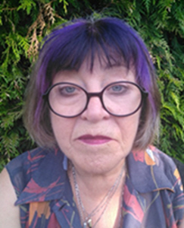
Pam Mitchell, Sussex Emmaus
I have worked in Trustee roles for many years. In addition to my role for Community Works, I have also been a Trustee and Vice Chair for Sussex Emmaus for the past 5 years and have until recently been Company Secretary and chaired the Companion Strategy Sub-Committee. I have just taken on a new role with responsibility for the wider Emmaus movement. I am also safeguarding lead.
In addition, I have been co-opted as a Trustee for FareShare Sussex & Surrey. My past career has been in senior roles in the charity sector since 1992, most recently as Transition Manager for FareShare Sussex. Other roles have been as CEO of Age UK East Grinstead & District, and Regional Manager for Age UK National, Headway and Gingerbread, as well as running the Lottery-funded Developing Communities Project for South Downs CVS and as Education and Training Manager for Mind in Wales.
I have a qualification in the Management of Voluntary Organisations from Southampton University as well as attaining a Personal Assistant qualification with East Sussex County Council. My passions are homelessness, mental health, and good quality recruitment.

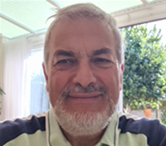
Ian Bretman, Healthwatch Brighton and Hove
I have lived in Worthing for the past two years, having relocated from London after retiring from full-time employment. My professional life has been focused on tackling inequality and promoting social justice and sustainability.
I played a central role for over 20 years in building the international Fairtrade movement, facilitating collaborations between development agencies and businesses, and supporting the efforts of communities in Africa, Asia and Latin America to secure a better deal from international trade in products like coffee, chocolate and bananas. More recently I have applied my experience to helping voluntary organisations and public services as a trustee or board member and consultant.
As well as chairing Community Works, I volunteer with Healthwatches in Sussex and represent them at local NHS meetings, and I am a governor at Hove Park School. I also chair Citizens Advice West Sussex, the national umbrella organisation for the Neighbourhood Watch movement and serve on the board of Timewise, a successful social enterprise which seeks to create a fairer jobs market through better use of flexible and part-time work.

