Sussex Mental Health Crisis and Wellbeing Support over the Festive Period

Page 1: Helpline, text and online support

Page 2: Staying Well Services

Page 3: VCSE offers Brighton & Hove, and East Sussex

Page 4: VCSE offers- Free Christmas meals across Sussex

Telephone

- NHS 111: ‘select the mental health option’: Available 24/7

- Samaritans: open 24/7 for support including mental health problems and emotional distress 01273 772277 or text 07725909090

- Switchboard: offers support for the LGBTQIA+ community. 10am—10pm. Call 0300 330 0630

- Head Space: an out-of-hours service for individuals who are reaching the point of a mental health crisis 6pm—midnight, seven days a week. Call 07890 257 614

Text Support

Shout: Text the word SUSSEX to 85258- Free, confidential, 24/7 support via a conversation with a trained volunteer.

Online/App

Grassroots Suicide Prevention Staying Alive App: The app is free and can be downloaded onto any phone.
Can be used by those at risk or individuals who are worried that someone is at risk: https://prevent-suicide.org.uk/find-help-now/stay-alive-app

MindOut online chat service: A free, confidential, and non-judgmental Online Support Live Chat service for individuals who identify as LGBTQA+: https://mindout.org.uk/get-support/mindout-online/

In-Person- Staying Well Service

An Out-of-hours walk-in service for people aged 18+ experiencing mental distress or requiring crisis support.
Safe space café provides peer and social support.
Call before you visit: (Freephone): 0800 023 6475, choose option #3
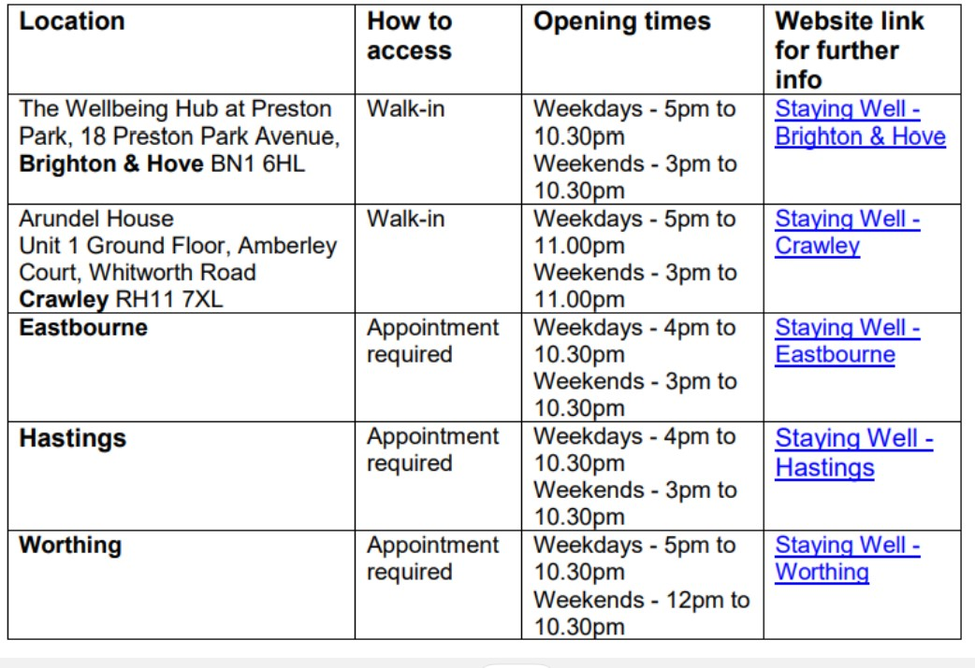

Staying Well Services Opening Hours
Christmas Eve: 3pm - 10.30pm
Christmas Day: 5pm - 10.30pm
Boxing Day: 5pm - 10.30pm
New Year’s Eve: 3pm - 10.30pm
New Years Day: 3pm - 10.30pm

Please go to the Sussex Partnership website for more information: https://www.sussexpartnership.nhs.uk/your-mental-health/getting-help/staying-well-services

Local VCSE offers

1. The Clare Project- Contact number: 07464 229395
Over 50s Group- Royal Pavilion Ice Rink Cafe, Brighton, BN1 1FN
- Monday 18th December 4:00pm - 6:00pm -,
Drop-in Dorset Gardens Methodist Church, Brighton, BN2 1RL
- Tuesday 19th December 2pm - 5pm
- Tuesday 2nd January 5pm-7pm

2. FSN Charity: IT drop-in on- Support for individuals around technology.
19th December- 9.30am-11.30am
2nd January 2024- 9.30am-11.30am
Address: FSN, 66 London Road St Leonards-on-Sea TN37 6AS
To book a slot please call: 01424 377115

3. Together Co: Christmas day online connect- 10am-11am
Run by two therapists, Together Co are offering an online space for 12 individuals to come together to connect and reflect with each other. Individuals can book via eventbrite
4. Seaview Project:
Open Access Wellbeing centre drop-in on 23rd and 30th December- 9-12pm
21st Free Christmas Dinner available to individuals. There are three time slots that individuals can choose to attend: 12pm, 12.30pm and 1pm.
Please Contact: 01424 717981 Address: Hatherley Road St Leonards-on-Sea East Sussex TN37 6LB

5. St John Ambulance Homelessness Service (nurse-led general healthcare needs) will be available at:
Warming Up The Homeless on Weds 27th Dec (Time TBC)- Address: 23 Priory Street, Hastings, TN34 1EA
Seaview on Fri 29th Dec 10:30am-1pm. Address: Hatherley Road St Leonards-on-Sea East Sussex TN37 6LB
For further information, please contact roger.nuttall@sja.org.uk

Free Christmas Meal: Brighton & Hove and East Sussex

Hove Salvation Army - 22nd and 25th December
The hall will be open from 10.30am to 3.30pm for people to come and go as they please. There will also be available a Christmas meal and activities.
Address: Conway Street, Hove, BN3 3LA 01273 323072
Sussex Homeless Support: 23rd and 29th December- Xmas Meal and other services at 1pm.
Address: 35b Providence Pl, Brighton and Hove, Brighton BN1 4GE
Warming up the homeless: The service is providing a free Christmas lunch and dinner on Sunday 10th, 17th, 24th dec- opening times is 4 – 7 pm
Address: 48 Devonshire Rd, Bexhill-on-Sea TN40 1AX 01424 552929

Free Christmas Meal- West Sussex

Soup kitchen: 25th December- Christmas day meal
Address: 35-36 Tarring Rd, West Worthing, Worthing BN11 4HP
Phone: 07984 766375

Turning Tides: Phone: 01903 680740
- 25th December- Christmas day lunch 9.30pm-1pm
Address: Littlehampton United Reformed Church, 1 High Street, Littlehampton, BN17 5EG

- 26th December- Boxing day meal 10.30am-1pm
Address: Town Hall, Chapel Rd, Worthing BN11 9SA

