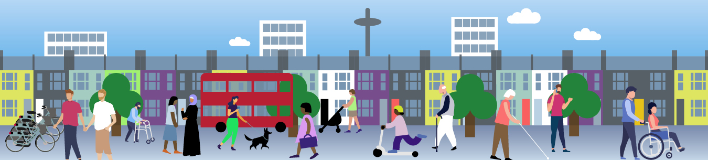

Community walking or wheeling* project
Funding application
(*Wheeling refers to the use of wheelchairs or mobility aids)

We are offering a grant of £500 or £1,000 to deliver and evaluate a walking or wheeling project which will benefit local residents of Brighton and Hove. The main aim of the project is to create an opportunity for adults who could gain from doing more walking to do so and experience its benefits. The main outcomes would ideally include reducing the number of car trips in favour of doing more walking and/or increase levels of physically activity especially amongst inactive or disengaged groups.
Applications are welcome from local community groups, schools and further and higher education institutions, development trusts and charities as well as public sector organisations. Deadline to submit applications is 28th September 2026. All applicants will be notified by 5th October. Please see walking project information sheet for more details.
Please email your application to delphine.jacq@brighton-hove.gov.uk. Please do not hesitate to get in touch if you have any questions or would like to discuss your project ideas.
Good luck!

- Organisation details

1.1 Organisation name:
1.2 Organisation address:
1.3 Organisation postcode:
1.4 Type of organisation:
1.5 Main contact name:
1.6 Main contact job title:
1.7 Main contact email:
1.8 Main contact phone number:
1.9 Overview of the organisation’s main activities:

- Proposal summary

2.1 Your proposal

Summarise your proposal, clearly demonstrating how your project will fulfil the main criteria (encourage people to do more walking in the city, reducing car trips if possible and targeting inactive groups)

We would like your project to include some of the following:
- Variety of routes and pace
- Accessibility and inclusion for disabled people and families
- Walks at convenient times for working people (evenings and weekends)
- Beginners/low Intensity or slower walking groups
- Special interest/themed walks
- Convenient starting points
Please include how many walks you plan to deliver, who would lead them and where they might take place. Also include details about your target group, how many participants will take part and how they will benefit from the activities not only during the project but beyond. Please specify if the same participants are likely to take part in most of the walks.

2.2 Please explain how you have consulted with the group involved in the project to determine their interest and/or possible level of engagement.

2.3 Funding – Explain how you propose to spend the funding

Please provide a detailed breakdown – Funding can be spent on refreshments, walking equipment, walking leader, bus tickets and more. Please get in touch if you are unsure how to allocate the funding.

- Project sustainability

If you are applying for the £1,000 grant, please explain how you intend to sustain the project beyond the funding period.

- Delivery

4.1 Delivery Start Date:
4.2 Delivery End Date:

- Monitoring and Evaluation

This funding is provided by Active Travel England which requires us to evaluate the impact of the projects. Taking part in this evaluation is essential. All participants will need to be asked to fill in pre and post questionnaires which will be provided. This information will enable us to understand what interventions work best and secure more funding in the future.

Please describe how you plan to make sure these questionnaires are completed by the participants. The questionnaires can either be done online or on paper. Your application is more likely to be successful if you are able to provide extra evaluation such as a case study, a short video or any other feedback that demonstrates the impact of your project.

Notes:

- £500 grants:
The total funding will need to be spent by 15th March 2027 at the latest. 50% of the grant will be transferred once you have been advised that you were successful and an informal face to face meeting has taken place. The other half will be transferred at the end of the project once the evaluation report has been received. The total grant allocation will be based on the financial breakdown provided in 2.3. The project evaluation (including the pre and post questionnaires and any other evaluation) will need to be submitted no later than 30th March 2027.

- £1,000 grants:
The total funding will need to be spent by 15th August 2027 at the latest. 50% of the grant will be transferred you have been advised that you were successful and an informal face to face meeting has taken place. The other half will be transferred at the end of the project once the evaluation report has been received. The total grant allocation will be based on the financial breakdown provided in 2.3. The project evaluation (including the pre and post questionnaires and any other evaluation) will need to be submitted no later than 30th August 2026.

- You will also be asked to provide a short report including a financial breakdown of your expenditures as well as a summary of the project outcomes.

- If the project is for any reason not able to start as planned, the grant will need to be returned.


