Funding available to set up a community walking or wheeling* project
(*Wheeling refers to the use of wheelchairs or mobility aids)
Brighton and Hove City Council is able to offer funding to help set up, run and evaluate a walking or wheeling project that would encourage more walking in the city.
The project needs to involve a specific group of adult participants who would agree to take part in a set number of walks. Ideally the same group would take part in all or most of the walks.
The project needs to be able to demonstrate that it will encourage inactive people to increase their walking and/or help them switch to walking from a less active mode of transport, especially for short trips within the city.
We would like the project to address some of the barriers to walking that have been highlighted in the past. Therefore, the proposal will need to include some of the following:
- Variety of routes and pace
- Accessibility and inclusion for disabled people and families or people with long-term health conditions
- Walks at convenient times for working people (evenings and weekends)
- Beginners/low Intensity or slower walking groups
- Special interest/themed walks
- Convenient and accessible starting points

The funding can be in spent in a variety of ways such as pay for refreshments, bus tickets, a specialist walk leader, walking equipment…
Minimum participants: 6
Two grants are available:
- Up to £500 - Minimum length of the project: 3 months
Timescale: the project needs to take place between November 2026 and March 2027
- Up to 1,000 – Minimum length of the project: 6 months
Timescale: the project needs to take place between November 2026 and August 2027
This project will require evidence that the project could be sustained beyond the funding period
Deadline to submit application: 28th September 2026
The funding is provided through the Consolidated Active Travel Fund managed by Active Travel England. There is a strong requirement to provide monitoring and evaluation via “before” and “after” surveys which will be provided. Therefore, the project participants will need to commit to this evaluation to order to be able to take part.
Applications are welcome from local community groups, schools, and higher education institutions, development trusts and charities as well as public sector organisations.
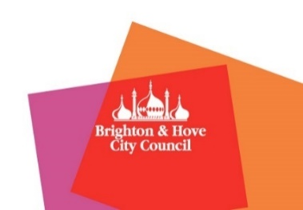
Please contact Delphine Jacq, Walking Officer for an application form and a chat at delphine.jacq@brighton-hove.gov.uk or by phone on 07594 647084.

