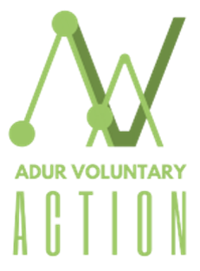


‘Building Connected, Inclusive & Resilient Communities’
- Date: Wednesday, 21 October 2026
- Time: 10:00am to 3:00pm (including a delicious free lunch)
- Venue: The Barn at Southwick Community Centre, 24 Southwick St, Southwick, Brighton BN42 4TE

10:00am | Arrival, drinks, and Networking
10:15am | Welcome and Housekeeping
10:20am | ‘Communities Together’– update on Adur Voluntary Action and Community Works partnership project  - Karen Macleod, CEO, Adur Voluntary Action and Jess Sumner, CEO, Community Works
10:30am | ‘What Leading with Joy in Community Work Can Teach You About Belonging’  - Bud Johnston and Annie Whilby Co-Founders, Black Anti-Racism Community Organisation (CIC)
11:30am | Tea Break and Networking
11:45am | ‘Introduction to LGBTQ+’  - Ben Dew, Training & Education Service Manager, Allsorts Youth Project
12:45am | Networking Lunch
1:30pm | ‘Beyond one size fits all – Working together with young adults to create inclusive environments’  - Emma Edwards, CEO, Esteem
2:45pm | Next steps & reflections
3:00pm | Finish

